# COMP 3612 Assignment #1: HTML + CSS

#### Version: 1.0 Sept 16 Due Monday October 7, 2024 at midnightish [i.e, I don’t care about several hours plus or minus]

## Overview

This assignment provides an opportunity for you to demonstrate your ability to work with HTML and CSS.

## Beginning

I feel foolish saying this in a third-year university course, but it is your responsibility to read all the assignment instructions thoroughly and carefully. If you are unclear about something, ask me. But before you do, read the material in question again!

Starting files can be found in the zip on D2L.

## Grading

The grade for this assignment will be broken down as follows:

CSS (accuracy, effort, suitability) 50%

Semantic HTML 15%

Functionality (follows requirements) 35%

## Data Files

Images have been provided. I have also provided a semicolon-separated text file which provides the text and data needed for the assignment pages.

## Requirements

This assignment consists of four HTML pages with the following functionality:

1. Your main assignment (home) page should **must** be named index.html.
2. Your main page should look quite similar to that shown in Chapter 4, Project 3. When I say “similar” I don’t mean “exactly identical” … different browsers, different browser widths, different platforms: all will affect the appearance somewhat. The purpose of this requirement is for you to learn how to implement a relatively straight-forward design *relatively* accurately.
3. The other pages can be styled in any way that you’d like. However, there is an expectation that these other pages follow the design language used in the main page. That means, use the same header, use the same fonts and probably similar colors, etc. That is, the other pages should look like they “belong” with the first page (this is what I mean by “suitability”).
4. If you make use of CSS recipes you found online or via AI, you must provide references (i.e., specify the URL where you found it or the prompt you used) via comments within your CSS file. **Failure to properly credit other people’s work in your CSS will likely result in a zero grade.** You can NOT make use of a third-party CSS library.
5. Most of the functionality in the assignment can be found in the sketches shown on the next few pages. The first shown below is the **Home Page**. Name this file index.html. In the textbook, pages 187-88 provide a bit more detail on implementing this page. Add styled buttons or links to the three cards (a card in web context means a box containing an image, title, and other content) which will take the user to the relevant page for that image. The provided data file (data.txt) has the content needed for this page, so you can simply copy+paste from the text file. The file names for the card images is the image’s id + “-small.jpg” (e.g., 1-small.jpg).

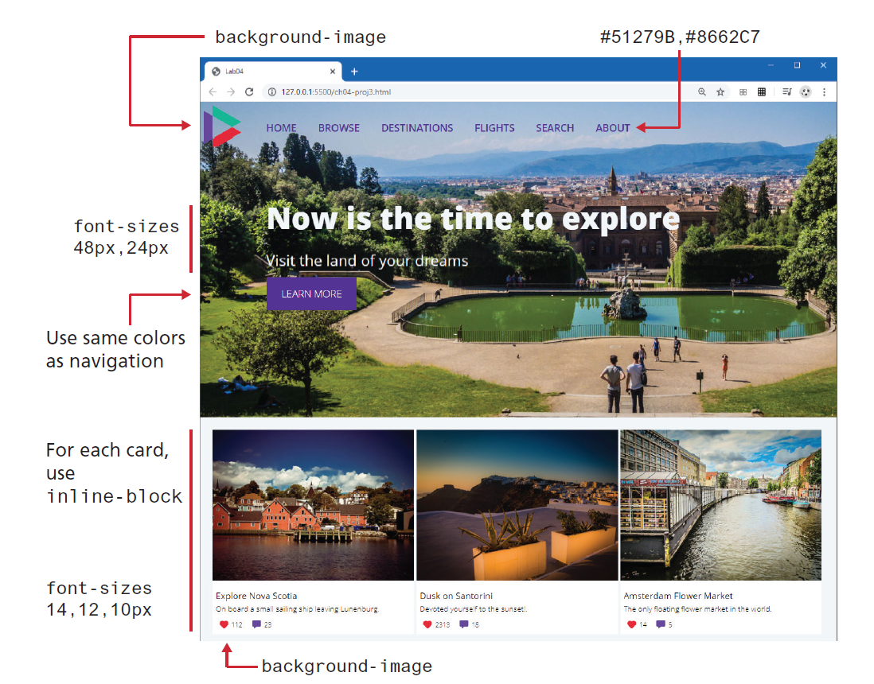

1. **Header**. Each of the items in the header should be a link with a hover style that changes the color of the text. The destination for the HOME link should be index.html, while the destination for the others should simply be dummy links to “#”.
2. **Footer.** Eachpage in the assignment should have the same footer. It should have a background color, with copyright statement and dummy links to About Us, Privacy Policy, and Sitemap.
3. **Individual Travel Image Pages**.This must display the information for a single travel image. You will thus have three different pages for the three different images. These pages must use the same CSS file. The sketch below illustrates the basic functionality.  
     
   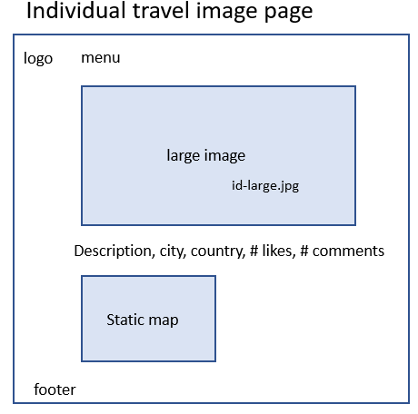  
     
   The provided data file (data.txt) has the content needed for this page, so you can simply copy+paste from the text file. The file names for the large image is the image’s id + “-large.jpg” (e.g., 1-large.jpg).  
     
   I have provided just a sketch here so that you can have practice implementing your own design. We have not covered CSS layout in our course, so I would NOT expect to see floats, positioning, flexbox or grids. You should probably stick with manipulating box properties (margin, padding, background, border, width, height) and using inline-block if you need items side-by-side. You are however welcome to make use of flexbox and grids layout mode if you really wish to have experience with it (indeed, I highly recommend learning grid layout since it will make styling assignment #2 much easier). Lab 7, Exercises 7.7 through to 7.17 can help you understand how to work with these modes.

You are welcome to make use of other images (e.g., icons for like and comments). If you do, please add a small sized credit line with the source URLs in the footer of the page.

1. **Map**. The static map is an image from mapquestapi.com using the latitude and longitude provided in the data file. You will need to sign up with mapquest developer (https://developer.mapquest.com/) in order to get an API key. Choose the Free account!  
     
   Once you have an account, go to the Manage Keys option and copy your consumer key.   
     
   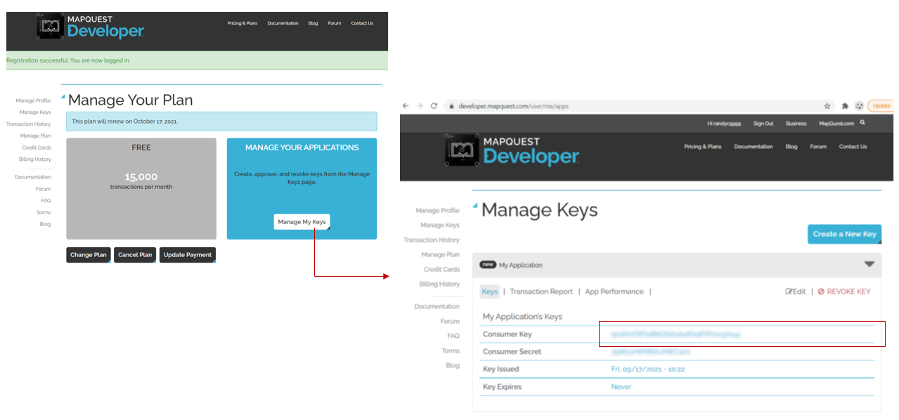  
     
   To display a map, you will need to use an <img> tag that references the mapquest static site. This requires your consumer key, the latitude and longitude to be displayed (provided in the data.txt file), and the width and height of the image.  
     
   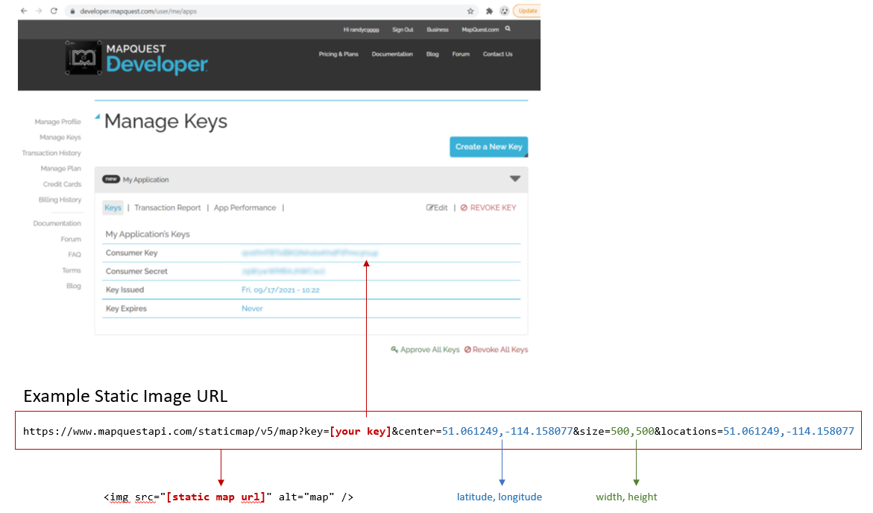  
   You can use any width and height that you like. They don’t have to be the same size.

## Submitting and Hosting

Your assignment source code must reside on GitHub and reside on a working public server (in this case GitHub Pages).

GitHub Pages works in conjunction with git and github. You push your html/css/images to github repo; and then push to the host. The instructions for doings so can be found at:  
  
https://docs.github.com/en/pages/getting-started-with-github-pages/creating-a-github-pages-site

It is up to you whether you want your pages to be public (available to the world) or private (available to only those with access to your github repo).   
  
If you are using a private repo, you must add me as a collaborator!

**When your hosting is working and the assignment is ready to be marked, then send me an email with the following information:**

* The URL of the home page of the site on github pages.
* The URL of the github repo so that I can mark the source code. If your repo is private, then add me as a collaborator!